**Final Report**

**Salon Player**

**(A single page application)**

Description of the project

Salon player is a single-page web application that acts as an online music player. This music player application allows users to browse and play music, create playlists, and add your favorite song to favorites list. The application work by loading all the necessary content and scripts on the initial page load, and then dynamically updating the content as the user interacts with the player.

This application consists of main section of page that displays the current content of application and two navigation bars: one at the top of page which contains search and settings for the users or register button if user has not logged in and the other one at the side of the page that contains two sections namely my music and my playlist. My music section has two buttons: recently played and my favorites. Recently played displays all the recently played tracks on the main section of page whereas my favorites display all the favorite tracks that user has liked. My playlist displays all playlists that user has created. However, features like recently played, my favorites and my playlist are only available to users if they have registered to the music application. Meanwhile, user can also utilize search option to search for any music. User can use setting to change/update their information, delete their account and logging out from the application.

Screenshots of the project

Landing page

#popular section

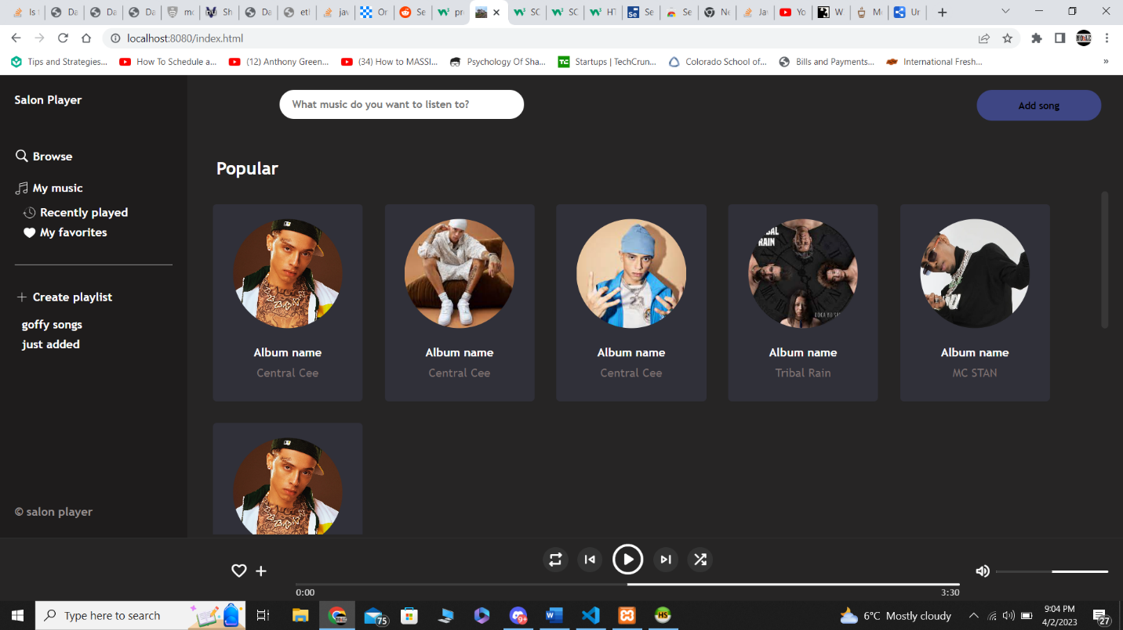

Favorite section

Recently played

Music playing

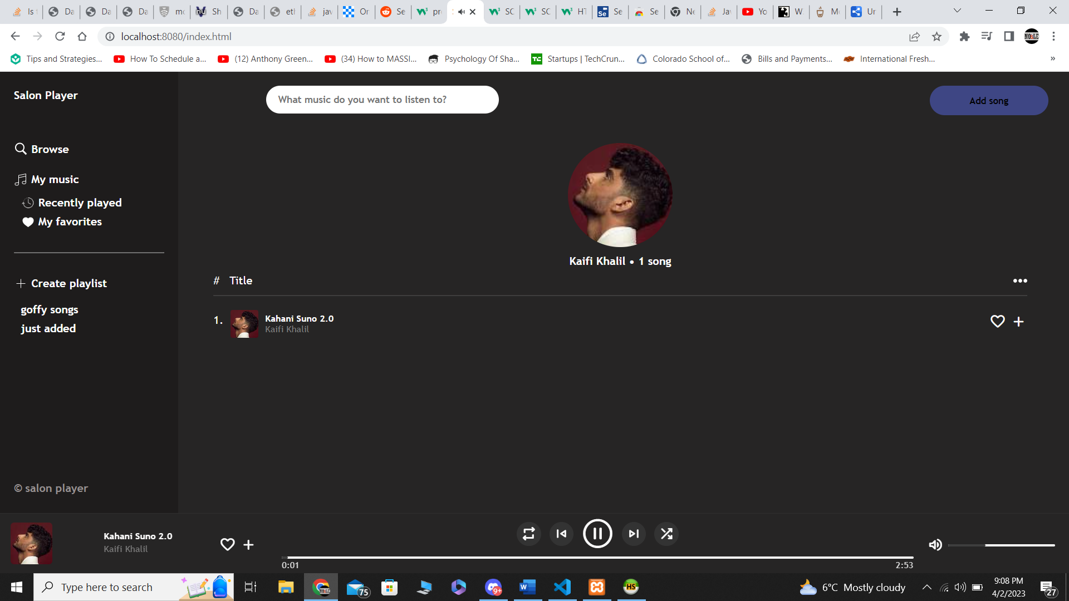

Adding audio

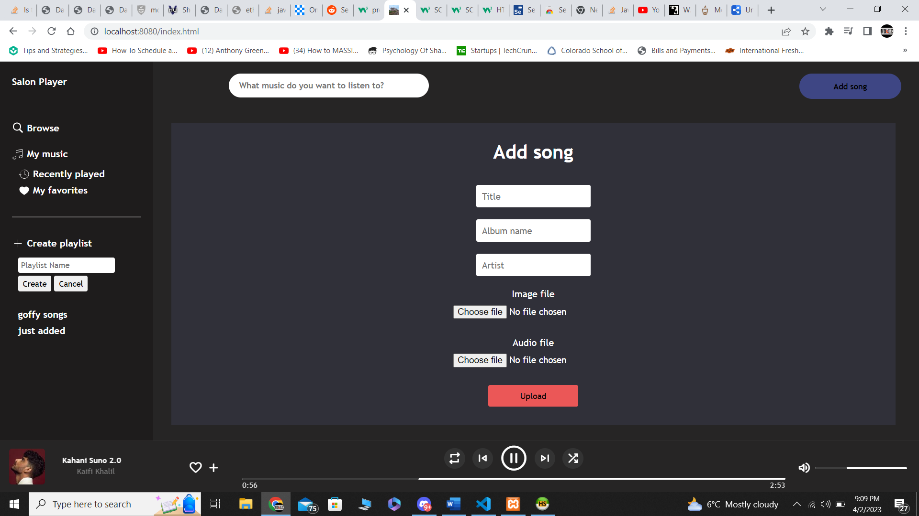

Database design of the project

This project has been using web technologies : Node.js, Javascript, HTML and CSS and MYSQL as database to store songs and user history.

[Note: This is not a complete project rather someone would consider it is a work in progress]